CECS 225

Lab1

Thanh Le

**Section 1**: HalfAdder Verilog module source

`timescale 1ns / 1ps

module HalfAdder(A, B, Cout, S);

input A, B;

output Cout, S;

assign Cout = A & B;

assign S = A ^ B;

endmodule

**Section 2**: HalfAdder Verilog Test Fixture

`timescale 1ns / 1ps

module HalfAdder_Tester;

// Inputs

reg A;

reg B;

// Outputs

wire Cout;

wire S;

// Instantiate the Unit Under Test (UUT)

HalfAdder uut (

.A(A),

.B(B),

.Cout(Cout),

.S(S)

);

initial begin

// test case 0

A = 0;

B = 0;

#10; //wait 10 time units

A = 0;

B = 1;

#10; //wait 10 time units

A = 1;

B = 0;

#10; //wait 10 time units

A = 1;

B = 1;

#10; //wait 10 time units

$stop; //end the stimulation

end

endmodule

**Section 3**: HalfAdder Simulation Screenshot

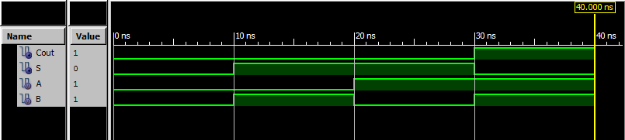

**Section 4**: FullAdder Verilog module source

`timescale 1ns / 1ps

module FullAdder(FA_A, FA_B, Cin, FA_S, Cout);

input FA_A, FA_B, Cin;

output FA_S, Cout;

wire ha0_S, ha0_C, ha1_C;

HalfAdder ha0( .A( FA_A ),

.B( FA_B ),

.Cout( ha0_C ),

.S( ha0_S )

);

HalfAdder ha1( .A( Cin ),

.B( ha0_S ),

.Cout( ha1_C ),

.S( FA_S )

);

assign Cout = ha0_C | ha1_C;

endmodule

**Section 5**: FullAdder Verilog Test Fixture

`timescale 1ns / 1ps

module FullAdder_Tester;

// Inputs

reg FA_A;

reg FA_B;

reg Cin;

// Outputs

wire FA_S;

wire Cout;

// Instantiate the Unit Under Test (UUT)

FullAdder uut (

.FA_A(FA_A),

.FA_B(FA_B),

.Cin(Cin),

.FA_S(FA_S),

.Cout(Cout)

);

initial begin

// test case 0

FA_A = 0;

FA_B = 0;

Cin = 0;

#10; //wait 10 time units

// test case 1

FA_A = 0;

FA_B = 1;

Cin = 0;

#10; //wait 10 time units

// test case 2

FA_A = 1;

FA_B = 0;

Cin = 0;

#10; //wait 10 time units

// test case 3

FA_A = 1;

FA_B = 1;

Cin = 0;

#10; //wait 10 time units

// test case 4

FA_A = 0;

FA_B = 0;

Cin = 1;

#10; //wait 10 time units

// test case 5

FA_A = 0;

FA_B = 1;

Cin = 1;

#10; //wait 10 time units

// test case 6

FA_A = 1;

FA_B = 0;

Cin = 1;

#10; //wait 10 time units

// test case 7

FA_A = 1;

FA_B = 1;

Cin = 1;

#10; //wait 10 time units

$stop; //end the stimulation

end

endmodule

**Section 6**: FullAdder Simulation Screenshot

